Availability Zones Review

Availability zones (collection of multiple data centers) protect your application infrastructure from any kind of issue (network, cooling power outage, patch upgrade) which cause down one data center but you still have application resources available in other region.

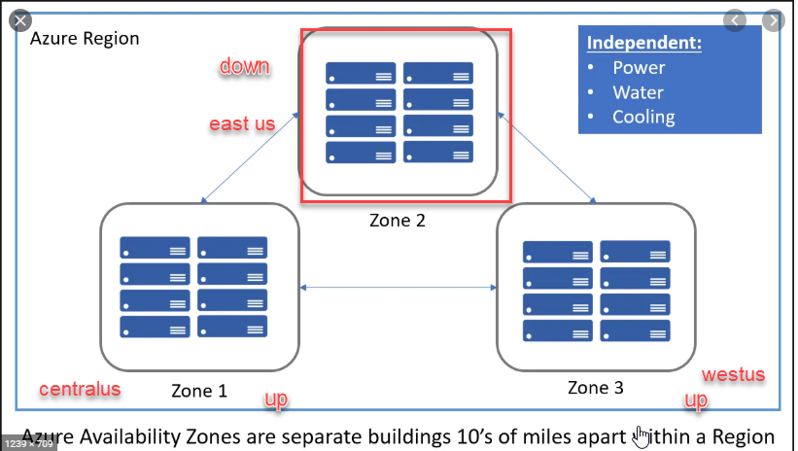

* provides better availability for your application by protecting them from datacenter failures.
* Each Availability zone is a unique physical location in an Azure region.
* Each zone comprises of one or more data centers that has independent power, cooling, and networking
* the physical separation of the Availability Zones helps protect applications against data center failures
* guaranteed an availability of 99.99% for your virtual machines. You need to ensure that you have 2 or more virtual machines running across multiple availability zones.

Lab: there is two ways you do the lab:

1.Creating virtual machine with availability zones

2. Creating virtual machine scale set where you get scale set + availability zones

For better understanding we will do the lab using no.2

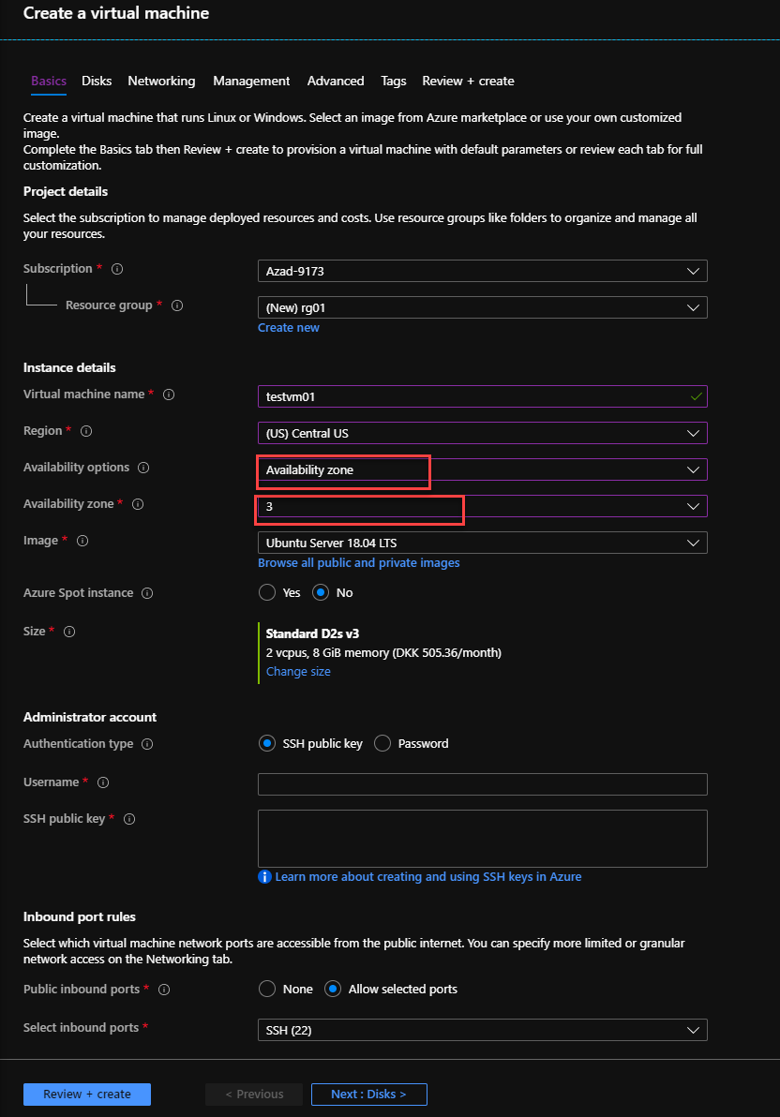

2. 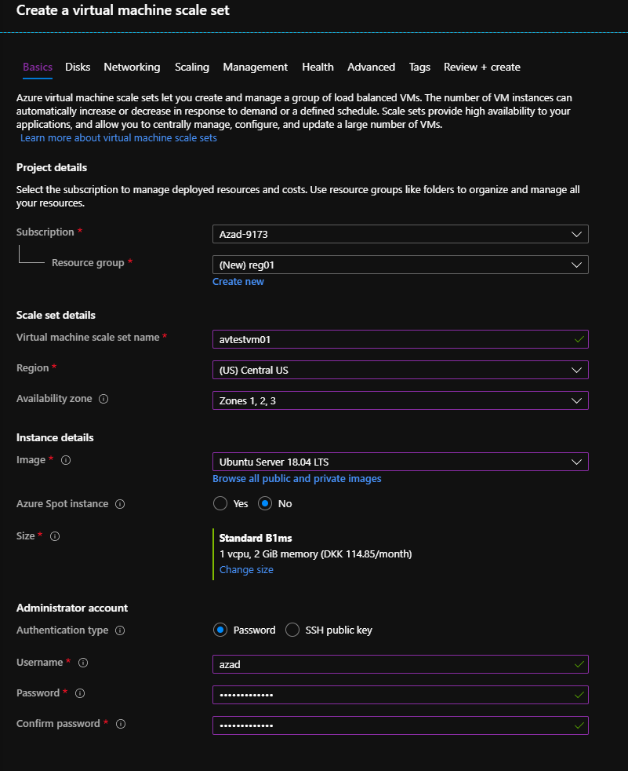

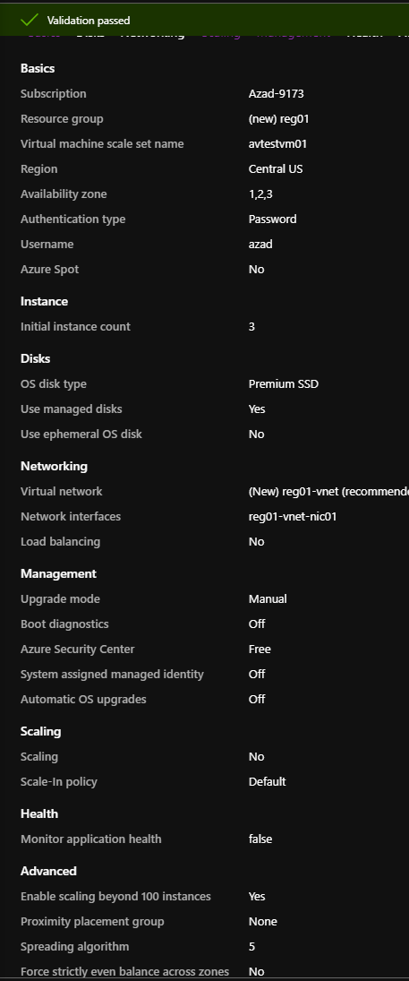

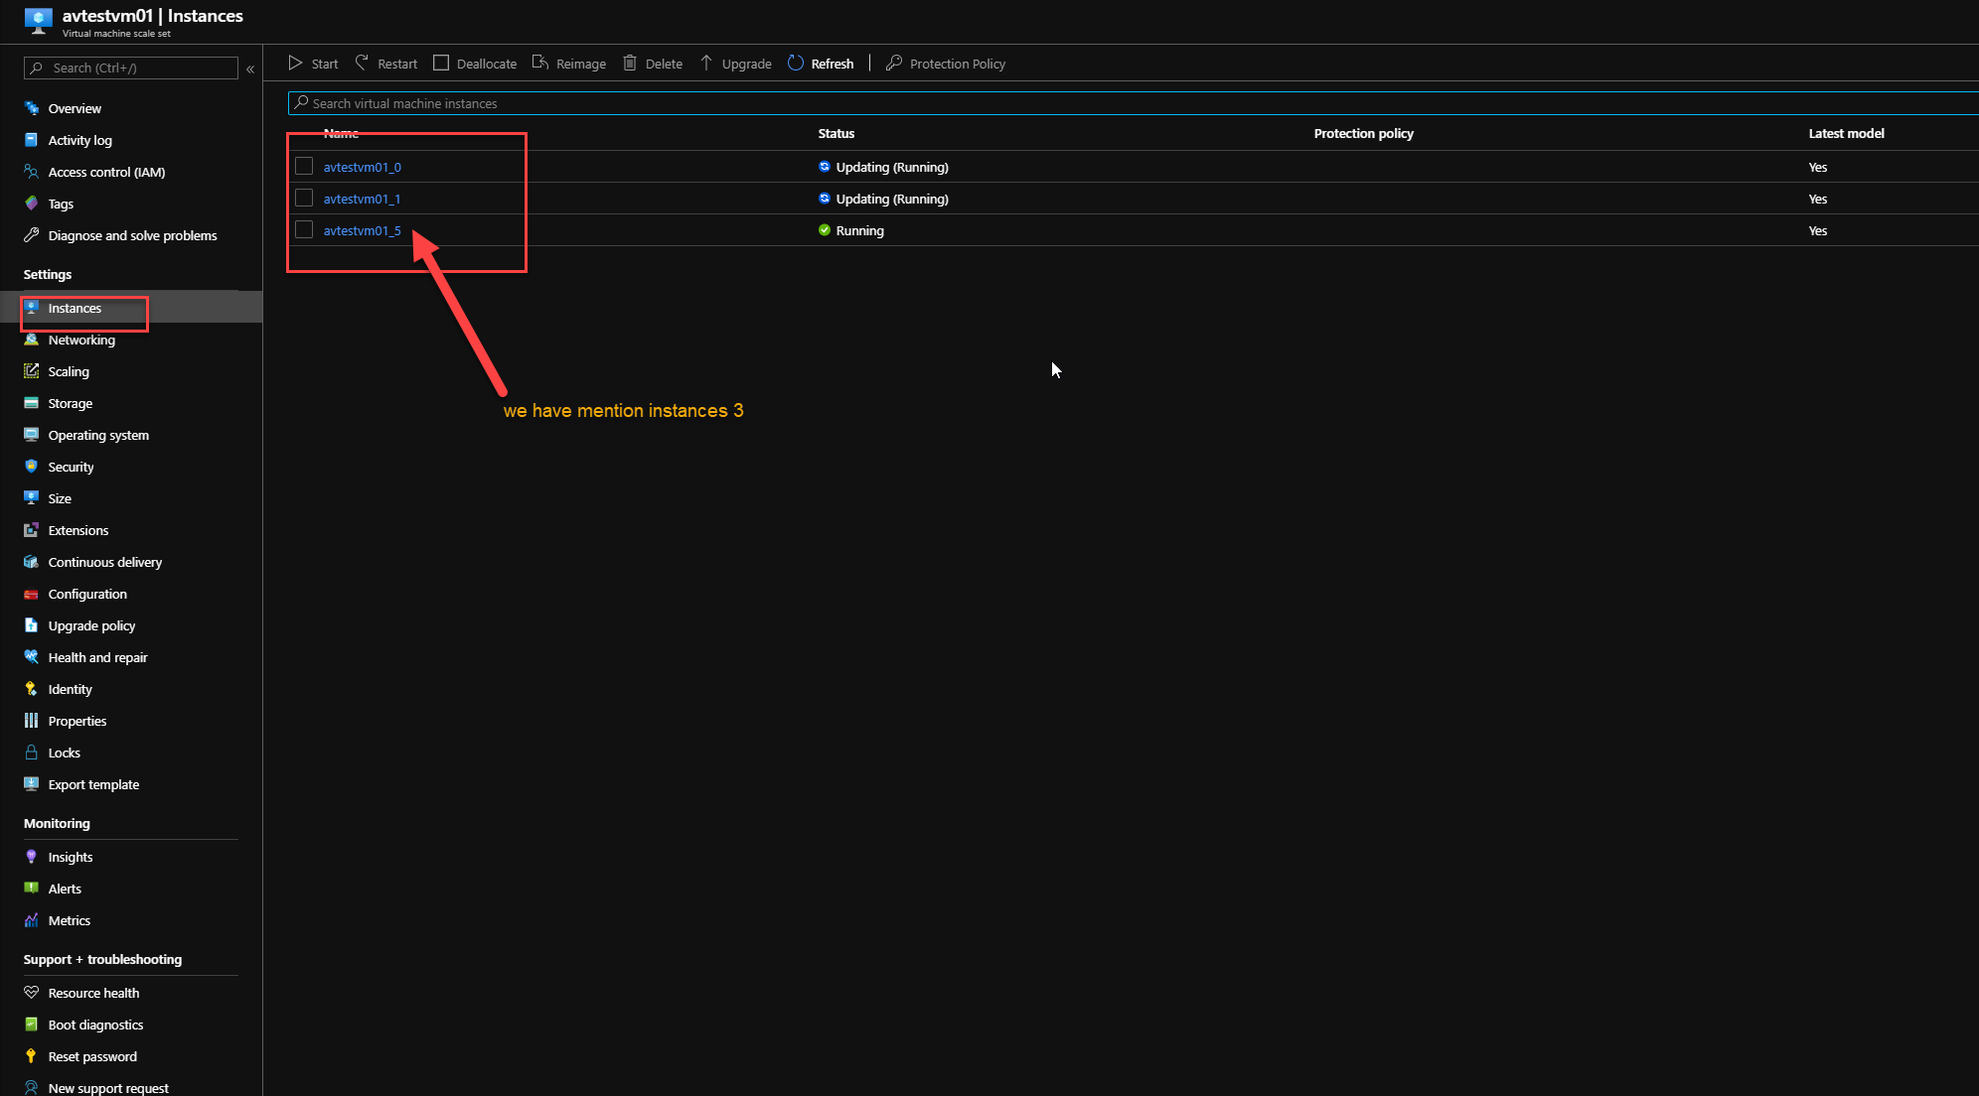

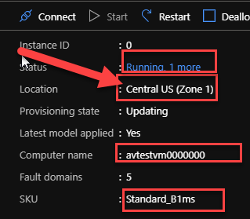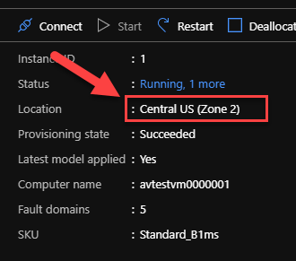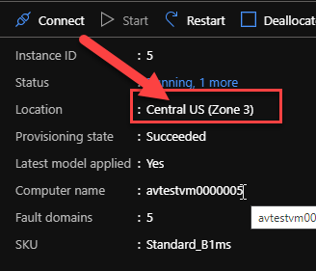

In this slide , we can see the instances we have set 3 and the region is 3 diffetent availability zones.